
EXERCISES FOR TENNIS ELBOW

If your doctor says it’s okay, do the following wrist stretch, finger stretch, and grip exercises daily and the other exercises three times a week, every other day (for example, Mondays, Wednesdays, and Fridays). Also, repeat the downward wrist stretch at the end of your exercise program.

You can do the stretching exercises before you play sports. Don’t do the strengthening exercises before you play sports because your muscles could get tired and you could get injured more easily.

It is important that you use smooth and controlled motions. Don’t jerk your wrist while doing the exercises. Put ice on your elbow until it is numb after you exercise.
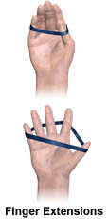
FINGER STRETCH WITH RUBBER BAND
Place a rubber band around your thumb and fingers and slightly cup your hand.
Gently spread your thumb and fingers apart then back together. Repeat the exercise 10 times, two – three times a day.

GRIP
Hold a soft object (for example, putty or a small rubber ball) in your hand and squeeze the object continuously for 10 to 15 minutes, two or three times a day.
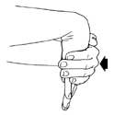
DOWNWARD WRIST STRETCH
Straighten the arm out fully and push the palm of the hand down so you feel a stretch across the top of the forearm. Hold for 15 to 30 seconds then relax, Repeat the exercise 2 – 3 times, two-three times a day.

WRIST CURL (PALM UP/PALM DOWN)
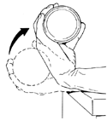
Place your forearm on a table or firm surface so that your elbow and forearm feels supported and relaxed, and then let your affected hand hang from the table. Your hand should be facing palm up at this position.
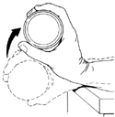
Now holding a dumbbell in your hand (start with a 1 pound hand weight and increase if too easy), try to flex/bend your wrist back or bring your knuckles facing up towards you as far as you can. And then relax down, still keeping your palm facing up. Repeat at least 10 times, twice a day.

Complete this exercise again but with your palm facing down.

ELBOW CURLS (PALM UP, PALM DOWN)
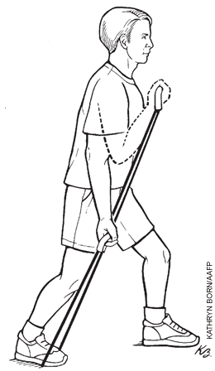
Step out so that one foot is in front of the other. Place one end of an exercise band under your back foot, and hold the other end with your hand using one of two grips. Pull the band up with your hand, and curl your arm toward your shoulder. You can use a dumbbell or barbell instead of an exercise band.
Repeat the curl exercise 10 times for three sets using both of the following grips: palm facing upward, and palm facing downward.

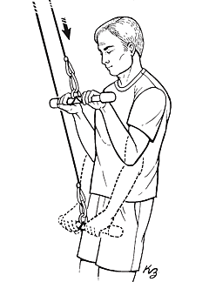

FOREARM PULL
Stand with your knees slightly bent. Hold the weight bar at shoulder level with your palms down and your upper arms close to the sides of your body. Push the weight down then back up. Repeat 10 times for three sets.

FOREARM TWIST
Sit with your forearm supported. Hold a hammer with your palm down. Gently rotate your forearm upward then downward as far as you can before feeling pain. If rotation is uncomfortable, move your hand closer to the hammer head. Repeat 10 times for three sets. You can use a dumbbell with a weight on one side instead of a hammer.
